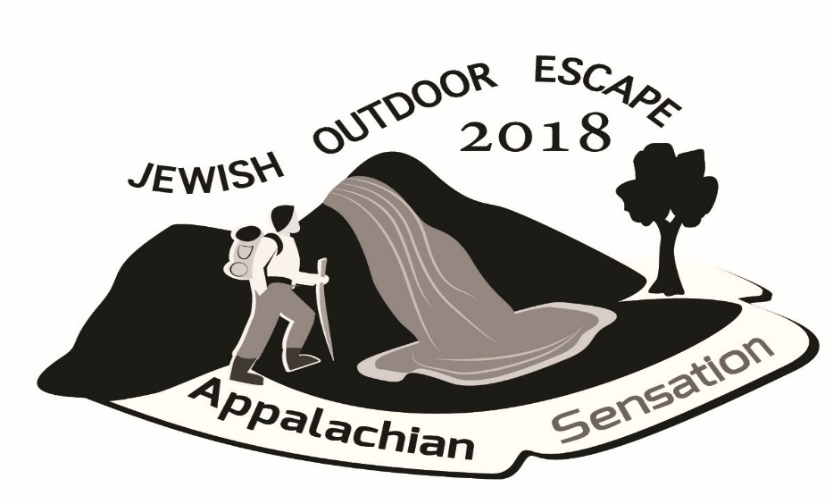
Join 120+ Jewish Outdoor Enthusiasts for an
AMAZING End of Summer Weekend!

It’s Summer Camp for Grown-ups

Hosted by Mosaic Outdoor Clubs of America

August 30 – September 3, 2018

Held in Morgantown, WV at Emma Kaufmann Camp

With a pre-trip in Pittsburgh, PA

Three to Five days of activities:
Whitewater Rafting  Biking  Canoeing  Kayaking  Climbing  Hiking at all levels
Spelunking in Laurel Caverns  Frank Lloyd Wright’s Fallingwater  Water Skiing
… and much more.
For all the details and to register visit
www.2018event.mosaicoutdoor.org

What is the Jewish Outdoor Escape?
Mosaic's Jewish Outdoor Escape is held every year during an extended Labor Day Weekend. It gives Jewish outdoor enthusiasts from all over the world the opportunity to spend time with each other in a Jewish setting and enjoy out-of-doors activities. We stay at a summer camp, and the activities vary each year depending on the locale. Over 100 like-minded Jewish adventurers attend this event each year.
What is Mosaic?
Mosaic Outdoor Clubs of America is a volunteer-run organization that allows Jewish adults with a love of the outdoors to get “back to nature” and have some fun. With 12 clubs located throughout the United States, Canada, and Israel, our international non-profit, volunteer-run organization promotes appreciation of the outdoors, nature, outdoor skills and conservation, while building Jewish community and continuity.
